Student Name: _________________________________ Date: ___________

Instructor Signature:_________________________________ Date: ___________

Point Assignment: ________________________
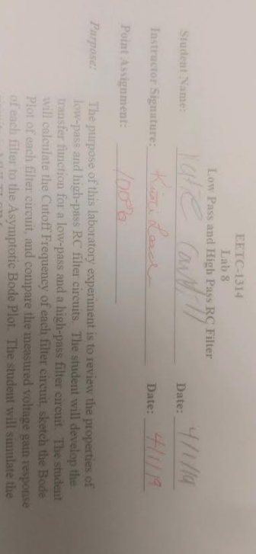
Purpose: The purpose of this laboratory experiment is to review the properties of low-pass and high-pass RC filter circuits. The student will develop the transfer function for a low-pass and a high-pass filter circuit. The student will calculate the Cutoff Frequency of each filter circuit, sketch the Bode Plot of each filter circuit, and compare the measured voltage gain response of each filter to the Asymptotic Bode Plot. The student will simulate the circuits in MULTI-SIM.

Procedure:

1. For the circuit shown in Figure 1, develop the transfer function as a function of the frequency, ω. Calculate the cutoff frequency, 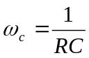. Sketch the magnitude vs. frequency Bode Plot on a semi-logarithmic scale (asymptote only). Is the circuit a low pass or high pass filter?

ω_{c} | 6447.45
TF

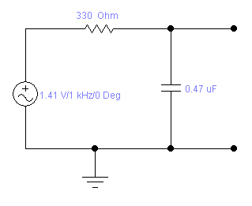
Figure #1 – Low Pass RC Filter

2. For the circuit shown in Figure 2, develop the transfer function as a function of the frequency, ω. Calculate the cutoff frequency, . Sketch the magnitude vs. frequency Bode Plot on a semi-logarithmic scale (asymptote only). Is the circuit a low pass or high pass filter?

ω_{c} | 6447.45
TF

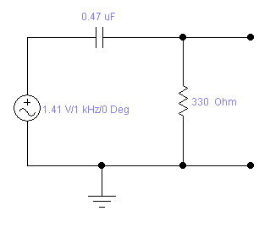
Figure #2 – High Pass RC Filter

3. Construct the circuit shown in figure #1 in MULTI-SIM. Connect channel #1 of the oscilloscope to the output of the signal generator and adjust the output to have an amplitude of 2 volts peak at a frequency of 100 hertz. Connect Channel #2 of the oscilloscope across the capacitor. Measure the amplitude of the capacitor voltage as the frequency increases as shown in table #1. Enter the result in the table shown. Determine the cutoff frequency by adjusting the frequency of the generator until the output voltage has an amplitude of V_{out}=0.707(2V)=1.41V. Use the measured values to calculate a gain, V_{out}/V_{in}.. Calculate the dB gain. Plot the dB gain in EXCEL on a semi-log graph. Compare the results and plot to the calculations and the asymptotic plot.

Table #1: Circuit #1 Measurements

Frequency, f | Frequency, ω | Amplitude  V_{out} | Gain  V_{out}/V_{in} | dB Gain  20log(V_{out}/V_{in})
100 Hz | 628.3185307 | 1.99 | 0.995 | -0.043538385
200 Hz | 1256.637061 | 1.96 | 0.98 | -0.175478486
400 Hz | 2513.274123 | 1.86 | 0.93 | -0.630341029
800 Hz | 5026.548246 | 1.57 | 0.785 | -2.102606865
1,000 Hz | 6283.185307 | 1.42 | 0.71 | -2.974833026
Cutoff 1025 | 6440.26494 | 1.41 | 0.705 | -3.03621766
2,000 Hz | 12566.37061 | 0.906 | 0.453 | -6.87803596
4,000 Hz | 25132.74123 | 0.495 | 0.2475 | -12.12849593
8,000 Hz | 50265.48246 | 0.253 | 0.1265 | -17.95818949
10,000 Hz | 62831.85307 | 0.203 | 0.1015 | -19.87067916
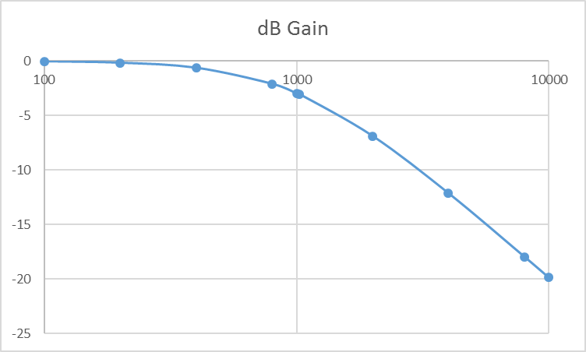
4. Construct the circuit shown in figure #2 in MULTI-SIM. Connect channel #1 of the oscilloscope to the output of the signal generator and adjust the output to have an amplitude of 2 volts peak at a frequency of 100 hertz. Connect Channel #2 of the oscilloscope across the resistor. Measure the amplitude of the resistor voltage as the frequency increases as shown in table #2. Enter the result in the table shown. Determine the cutoff frequency by adjusting the frequency of the generator until the output voltage has an amplitude of V_{out}=0.707(2V)=1.41V. Use the measured values to calculate a gain, V_{out}/V_{in}.. Calculate the dB gain. Plot the dB gain in EXCEL on a same semi-log graph. Compare the results and plot to the calculations and the asymptotic plot.

Table #2: Circuit #2 Measurements

Frequency, f | Frequency, ω | Amplitude  V_{out} | Gain  V_{out}/V_{in} | dB Gain  20log(V_{out}/V_{in})
100 Hz | 628.3185307 | 0.194 | 0.097 | -20.26456531
200 Hz | 1256.637061 | 0.207 | 0.1035 | -19.701193
400 Hz | 2513.274123 | 0.375 | 0.1875 | -14.53997456
800 Hz | 5026.548246 | 1.23 | 0.615 | -4.222497684
1,000 Hz | 6283.185307 | 1.39 | 0.695 | -3.160303908
cutoff | 6440.26494 | 1.41 | 0.705 | -3.03621766
2,000 Hz | 12566.37061 | 1.77 | 0.885 | -1.061134586
4,000 Hz | 25132.74123 | 1.93 | 0.965 | -0.309453733
8,000 Hz | 50265.48246 | 1.98 | 0.99 | -0.087296108
10,000 Hz | 62831.85307 | 1.98 | 0.99 | -0.087296108

